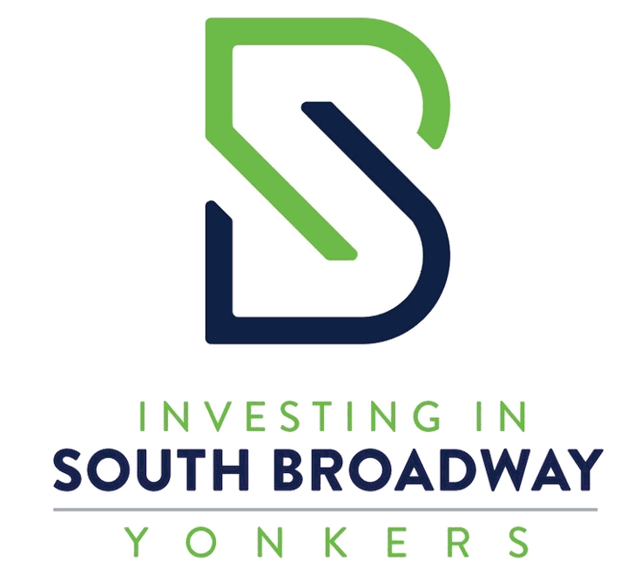

South Broadway Community Survey
Help the City plan for the next 5 to 10 years
South Broadway is part of everyday life in Yonkers. We want to hear from the people who live, work, shop, travel, and spend time here. Your answers will help guide future conversations about businesses, housing, transportation, public spaces, and the character of the corridor.
Estimated time: 7 minutes
1 How are you connected to South Broadway?
Select all that apply.
☐ I live on or near South Broadway | ☐ I work or attend school on or near South Broadway
☐ I own or operate a business nearby | ☐ I shop, dine, or use services nearby
☐ I travel along South Broadway to reach other destinations | ☐ I visit occasionally
☐ I do not currently visit regularly
☐ Other: ________________________________________________
2 What would you like to see more of on South Broadway?
Choose up to five.
☐ Grocery stores and fresh-food options | ☐ Restaurants, cafés, and bakeries
☐ Local shops and small businesses | ☐ Healthcare and personal services
☐ Arts, culture, and entertainment | ☐ Parks, plazas, and places to gather
☐ Activities and services for young people | ☐ Resources for older adults
☐ Community or educational spaces | ☐ Housing choices
☐ Jobs and employment opportunities | ☐ Other

Community Priorities
3 What are your top priorities for improving South Broadway?
Choose up to three.
☐ Support existing local businesses | ☐ Attract new shops and services
☐ Improve cleanliness and maintenance | ☐ Make streets and sidewalks safer
☐ Improve bus service | ☐ Add trees and public gathering spaces
☐ Preserve neighborhood character | ☐ Create more housing choices
☐ Improve building appearances and storefronts | ☐ Other
4 What kinds of housing, if any, should be considered?
Choose up to three.
☐ Affordable rental apartments | ☐ Mixed-income housing
☐ Market-rate apartments | ☐ Homeownership opportunities
☐ Senior housing | ☐ Accessible housing
☐ Housing above stores and businesses | ☐ No additional housing
☐ I am not sure | ☐ Other
Where, if anywhere, could additional housing be appropriate?
☐ North Gateway | ☐ Ludlow Station Area
☐ South Broadway Main Street | ☐ South Gateway
☐ Throughout the corridor | ☐ Nowhere along the corridor
☐ I am not sure
5 Which transportation and street improvements matter most?
Choose up to three.
☐ Safer street crossings | ☐ Better-maintained or wider sidewalks
☐ Better lighting | ☐ More reliable bus service
☐ Real-time bus arrival displays | ☐ Safer bicycle connections
☐ ADA accessibility improvements | ☐ Traffic-calming measures
☐ More parking | ☐ Better delivery and loading areas
☐ Street trees, benches, and landscaping | ☐ Other

Find Your Section
Use this map when a question asks where an idea or type of development may be appropriate. The colors run from north to south along South Broadway.
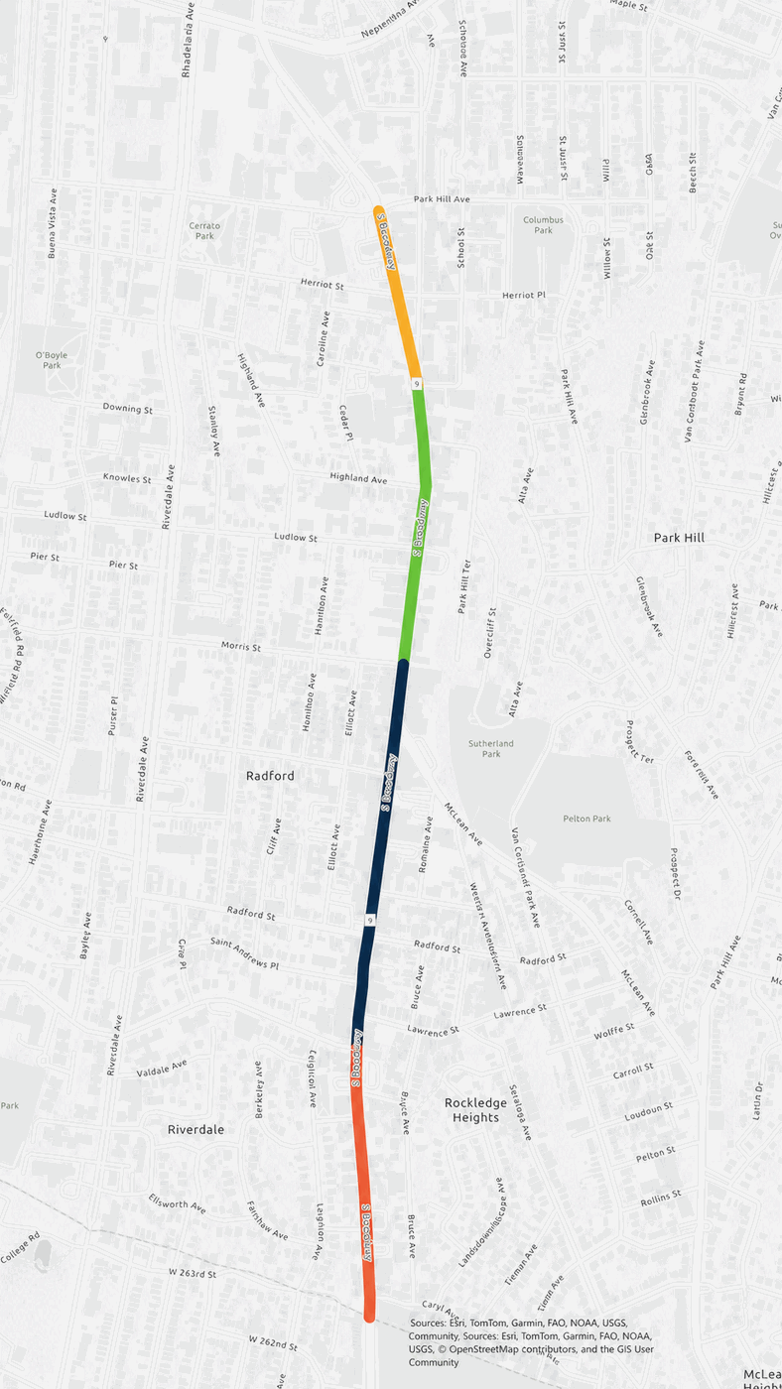
■ North Gateway - Park Hill Avenue to Bright Place
■ Ludlow Station Area - Bright Place to Morris Street
■ South Broadway Main Street - Morris Street to Valentine Lane
■ South Gateway - Valentine Lane to Caryl Avenue
These sections are a planning tool used to organize feedback. They do not create new rules for any block.

Development Examples
South Broadway could remain mostly as it is today, or it could gradually change to include more businesses, housing, and street improvements. These photographs show different possibilities, not proposed projects. For each one, tell us whether you would like to see more places like it and where they might be appropriate.
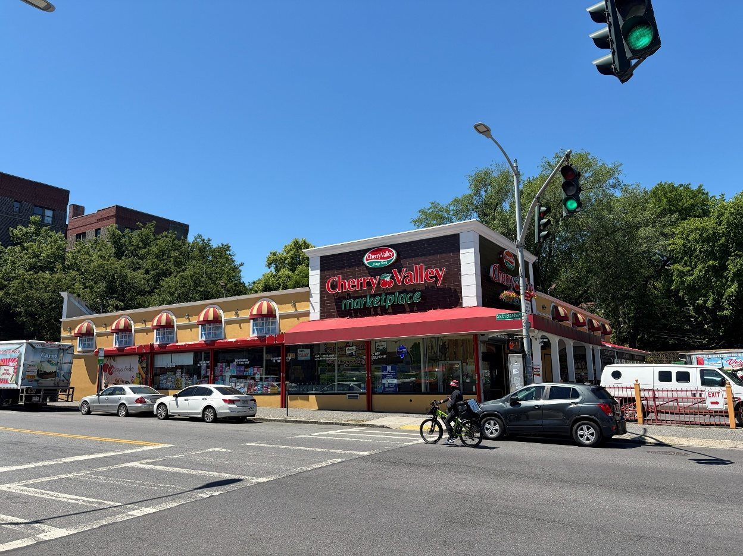
Example A Keep buildings mostly as they are
A one-story business with no housing above it.
Would you like to see more places like this along South Broadway?
☐ Definitely yes ☐ Probably yes ☐ Not sure ☐ Probably no ☐ Definitely no
If yes, where would it be most appropriate?
☐ North Gateway ☐ Ludlow Station Area ☐ South Broadway Main Street ☐ South Gateway ☐ Anywhere appropriate
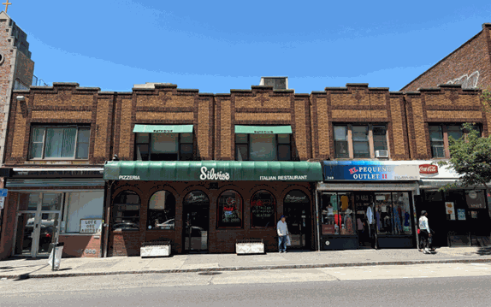
Example B Small-scale neighborhood storefronts
Shops or restaurants in buildings about two stories tall.
Would you like to see more places like this along South Broadway?
☐ Definitely yes ☐ Probably yes ☐ Not sure ☐ Probably no ☐ Definitely no
If yes, where would it be most appropriate?
☐ North Gateway ☐ Ludlow Station Area ☐ South Broadway Main Street ☐ South Gateway ☐ Anywhere appropriate

Development Examples
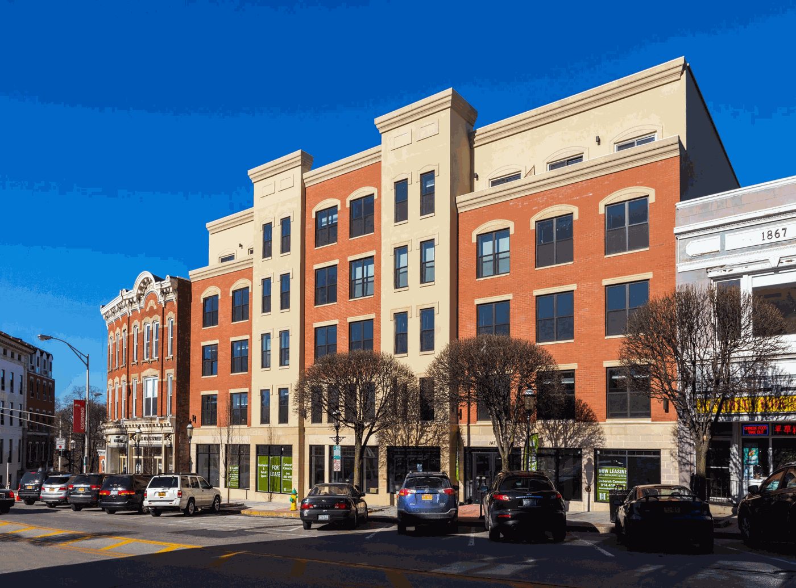
Example C Moderate growth with housing above stores
A building about five stories tall, with businesses at street level and apartments above.
Would you like to see more places like this along South Broadway?
☐ Definitely yes ☐ Probably yes ☐ Not sure ☐ Probably no ☐ Definitely no
If yes, where would it be most appropriate?
☐ North Gateway ☐ Ludlow Station Area ☐ South Broadway Main Street ☐ South Gateway ☐ Anywhere appropriate
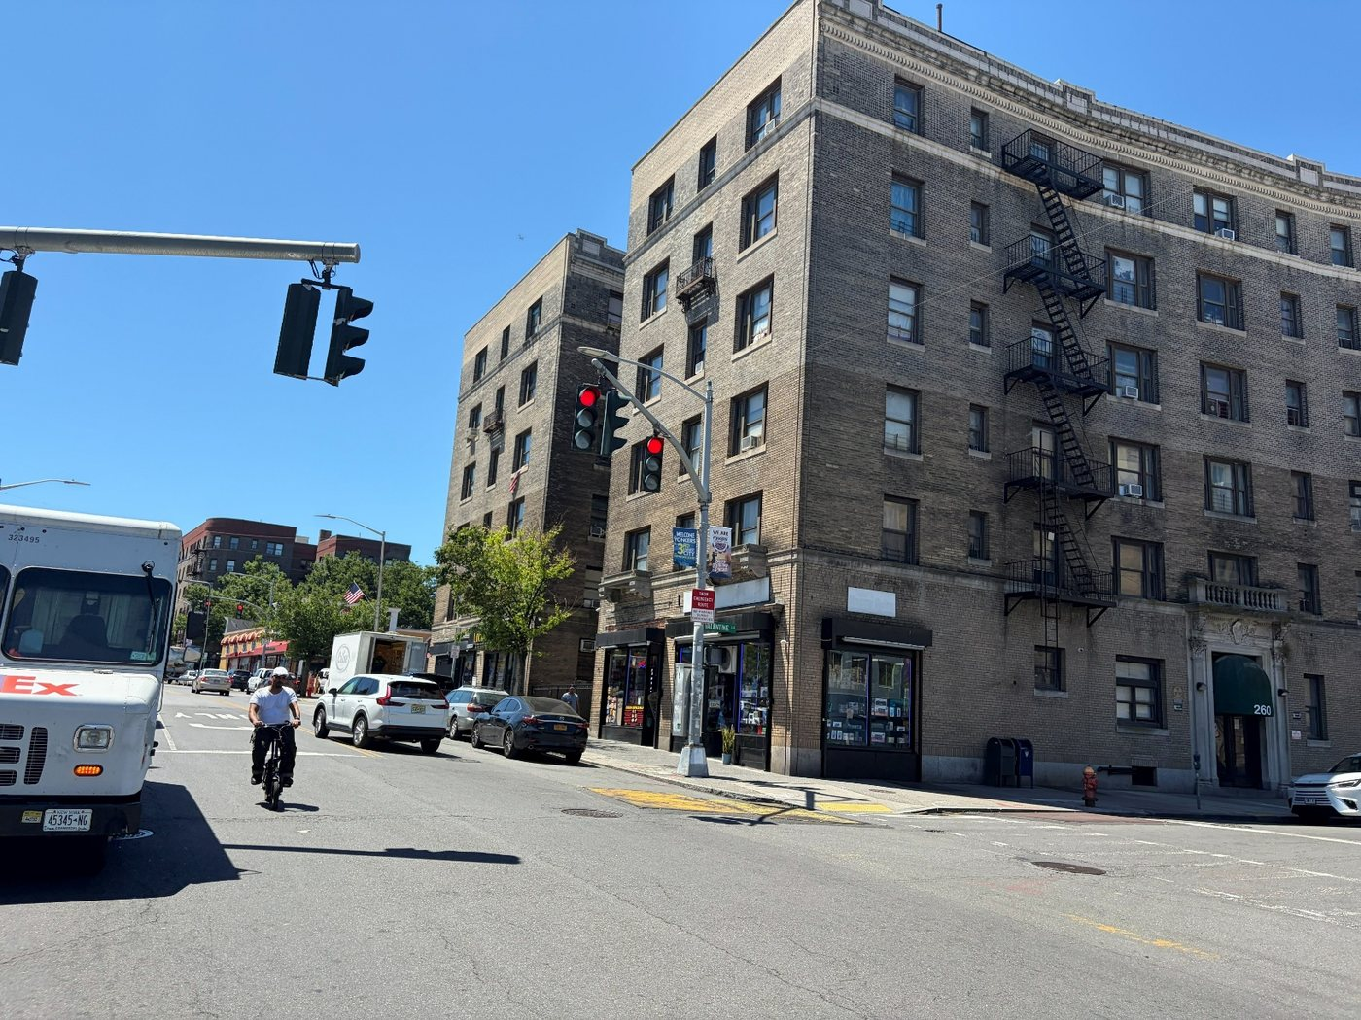
Example D Taller mixed-use development
A building about six stories tall, with businesses at street level and apartments above.
Would you like to see more places like this along South Broadway?
☐ Definitely yes ☐ Probably yes ☐ Not sure ☐ Probably no ☐ Definitely no
If yes, where would it be most appropriate?
☐ North Gateway ☐ Ludlow Station Area ☐ South Broadway Main Street ☐ South Gateway ☐ Anywhere appropriate

Development Examples
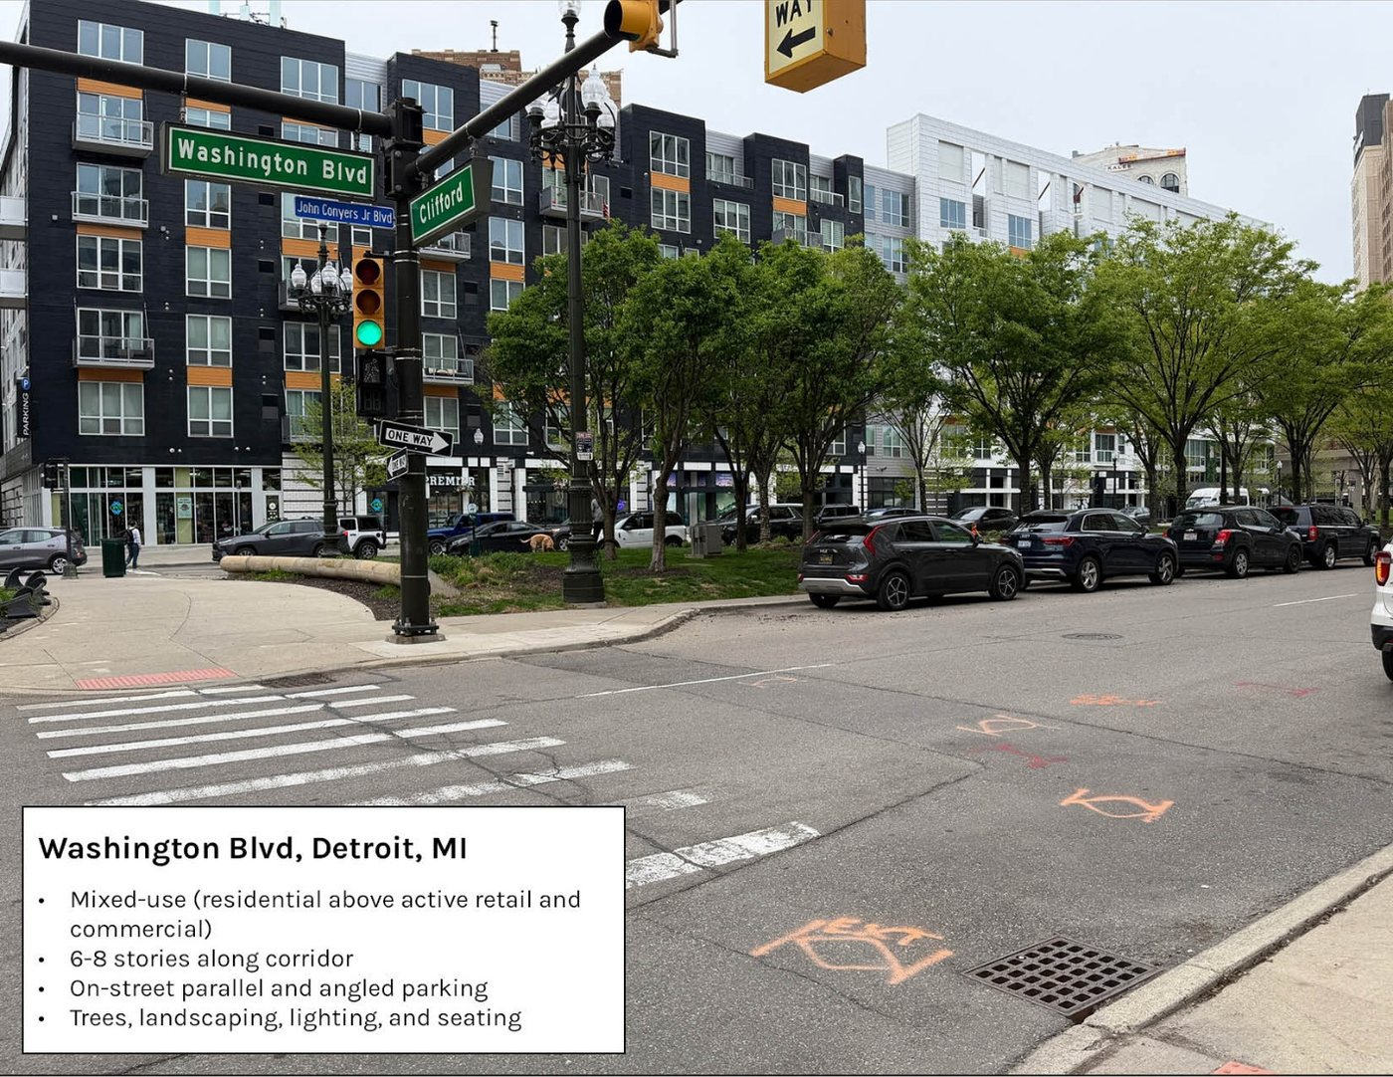
Example E A more fully redesigned commercial corridor
Housing and storefronts combined with trees, sidewalks, public space, and organized parking.
Would you like to see more places like this along South Broadway?
☐ Definitely yes ☐ Probably yes ☐ Not sure ☐ Probably no ☐ Definitely no
If yes, where would it be most appropriate?
☐ North Gateway ☐ Ludlow Station Area ☐ South Broadway Main Street ☐ South Gateway ☐ Anywhere appropriate

Development Examples
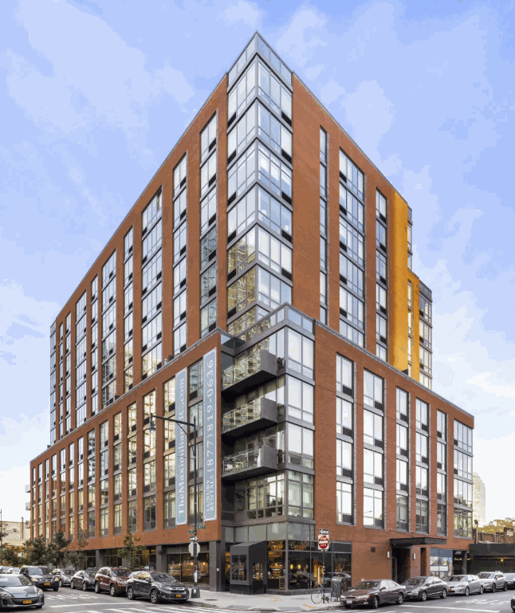
Example F Taller mixed-use building
A building about 12 stories tall, with apartments above street-level businesses.
Would you like to see more places like this along South Broadway?
☐ Definitely yes ☐ Probably yes ☐ Not sure ☐ Probably no ☐ Definitely no
If yes, where would it be most appropriate?
☐ North Gateway ☐ Ludlow Station Area ☐ South Broadway Main Street ☐ South Gateway ☐ Anywhere appropriate
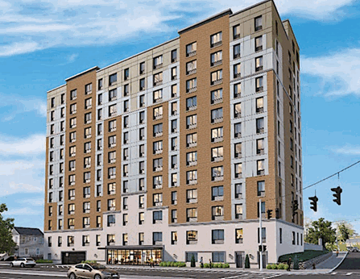
Example G Proposed Riverdale apartment building
A proposed taller apartment building shown as an example of scale and design.
Would you like to see more places like this along South Broadway?
☐ Definitely yes ☐ Probably yes ☐ Not sure ☐ Probably no ☐ Definitely no
If yes, where would it be most appropriate?
☐ North Gateway ☐ Ludlow Station Area ☐ South Broadway Main Street ☐ South Gateway ☐ Anywhere appropriate
What influenced your answers?
☐ Building height | ☐ Stores and businesses
☐ Housing | ☐ Architecture or appearance
☐ Trees and public space | ☐ Sidewalk and street design
☐ Parking or traffic | ☐ Other
Is there anything you especially liked or disliked about these examples?
_________________________________________________________________________________________________________
_________________________________________________________________________________________________________
6 What else should the City understand about South Broadway as it plans for the future?
Optional.
_________________________________________________________________________________________________________

Optional Information
These questions help us understand whether we are hearing from different parts of the community. You may complete the survey without providing contact information.
Age range (optional)
☐ Under 18 ☐ 18–24 ☐ 25–34 ☐ 35–44 ☐ 45–54
☐ 55–64 ☐ 65–74 ☐ 75 or older ☐ Prefer not to answer
ZIP code: ________________________________________________________
Nearest cross street or section of South Broadway: ________________________________________________________
Email address for project updates: ________________________________________________________

